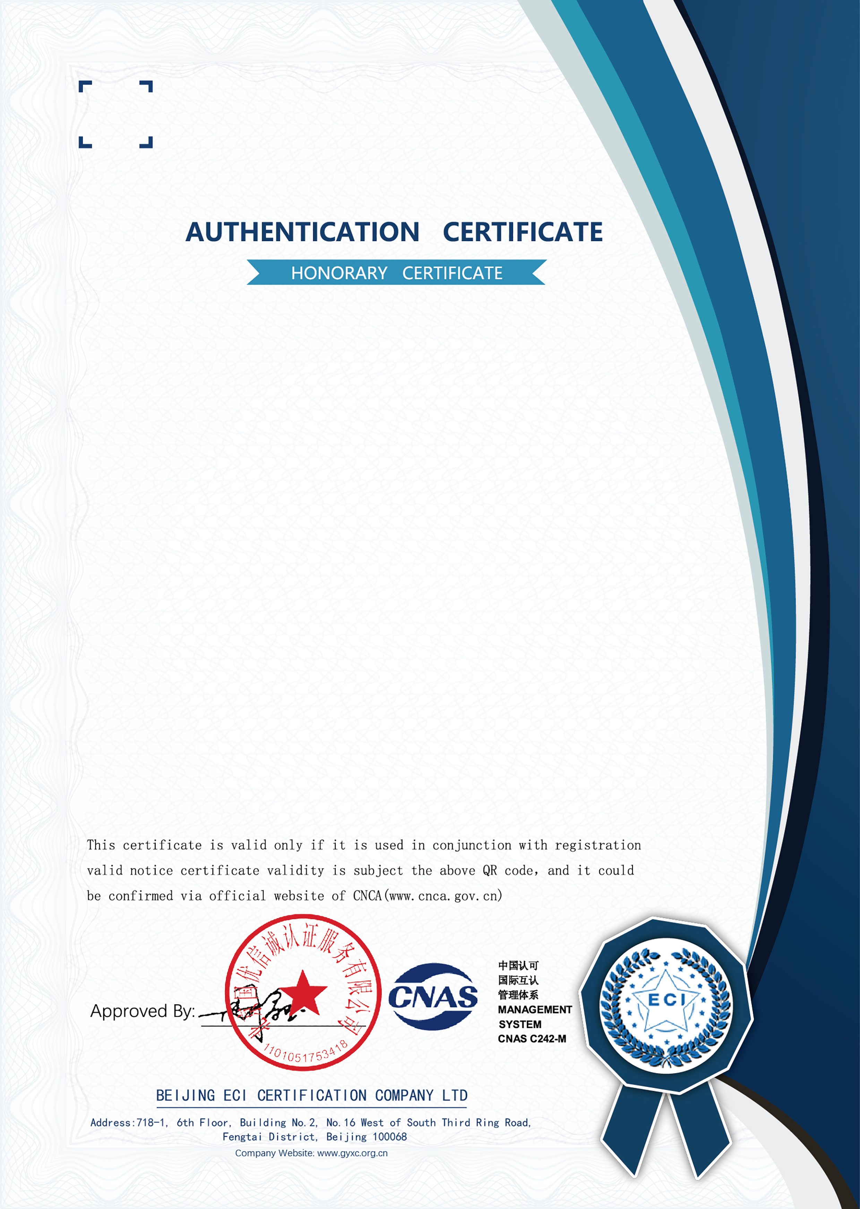


TIANJIN YUANTAI DERUN PIPE
MANUFACTURING GROUP CO.,LTD
NO:ECI21S10064R0M
Organization Code:911200005503823816
Register Address: DAQIUZHUANG INDUSTRIAL ZONE JINGHAI TIANJIN
CHINA . Post Code:301606
Production Address: DAQIUZHUANG INDUSTRIAL ZONE JINGHAI TIANJIN
CHINA . Post Code:301606
Is in conformity with
GB/T45001-2020/ISO45001:2018 Standard
Authentication Scope
SALES AND SERVICE OF HOLLOW SECTION, HOT DIP
GALVANIZED HOLLOW SECTION, METAL MATERIAL AND
RELEVANT LABOUR HEALTH AND SAFETY MANAGEMENT
ACTIVITIES (Exceptions to the scope of legal enforcement)

Date of issue: 11-05-2021 Date of valid: 10-05-2024

